**Engineering Systems Design 1**

**Design of a Wind-Powered Water Storage, Pumping, and Treatment System**

**(Draft)**

**Team Members**:

* Kaijian Zheng (904762)
* Catherine Yuen (915072)
* Runfeng Li (904791)
* Zimo Wang (900915)
* Xulin Yang (904904)
* Jianrong He (823332)

**Course:**

Engineering Systems Design 1

**Team Name:**

Table 3 :)

**Date of submission:**

12 May 2017

Abstract

Water is one of the most essential elements for life. Since only 3% of Earth’s water is drinkable, building sustainable drinking water treatment systems for communities is necessary and important. For this project, our group was required to design and build a drinking water system for a remote community of 2000 residents that would last for ten years. Water from an underground well is transferred into the system, and after a series of processes, the treated water is provided to the residents. In addition, due to the effects of global warming and the advantages of using renewable energy, our group will use wind power to pump and control water in the system.

Furthermore,, our group found that the daily water demand for this community is 3715 liters. With a population growth rate of 1.2%, and an estimated 10th year population of 2254, the daily demand for water at the end of ten years is about 4188 liters. The most suitable and cheapest material for the tank is PE plastic and galvanized steel, and the best shape for the tank is a cylinder.

Table of Contents - index:

# 

# 

# 

# 

# 

# 1. Introduction:

Purpose and Aim:

The purpose of this report is to show the proposed design of the water system. The aim of the project is to design a water pumping, storage and purify system with renewable energy.

Context and Background Information:

Providing clean and safe drinking water for this remote community is a basic but essential need for development. By installing this drinking water system, the quality of life in this area will be improved. This design provides a automatic drinking water system which can be the most suitable service for current condition.

The project aims to design and build a sustainable, safe, low cost and easily maintained drinking water system for a community of around 2000 residents with an average population growth rate of 1.2% over a period of ten years. This system is divided into four modules: water storage, pumping and control, power provision, and water treatment.

The scope of this design includes the wind turbine power generation, pump and pipe system, water storage tank, and the water treatment module. The elements of the system that are out of the scope for this design are: electricity storage from the wind turbine for the pump when there is no wind supply, and the design of the pipe connecting the water storage tank to the water treatment tank.

The community is located on a flat, semi-arial area near a water well. The system is to be built 200 metres from the centre of the community, 10 metres away from a water well 35 metres deep. Because the system is so close to the community, factors such as size and safety had to be taken into account when designing the system. In terms of climate, the temperatures to be experienced by the system are fairly moderate. The yearly average high temperature is 31 degrees, while the yearly average low temperature is 21 degrees. The lowest temperature ever recorded was 4 degrees, 75 years ago. The average rainfall in the summer is 110mm, which drops to an average of a few millimetres during the dry season in winter and spring. However, this factor did not affect the design of the system as it was assumed that rainfall would not affect an unlimited supply of water in the well.

There were a number of restrictions on the dimensions of the system. The water storage tank is to be built on a tower structure 10 meters above the ground, to allow for gravity driven flow and to prevent people tampering with the system. Because of this constraint, the design must be light enough for the structure and the ground to support its weight.

The key factor we investigated throughout the course of the project was data gathered from tank drainage, pumping, and wind turbine experiments on a small scale testing model of our real world design. In addition, data from the design specifications was taken into account for our design. These included: average wind speed data; average weather and climate conditions and details about the location of the community and the well. All this relevant data is in the appendices.

Our group followed a logical approach to the design of the system. The first step is to decide the tank size so that the orifice size can be chosen. For this stage, our design limited the outflow rate at the first tank. As long as the flow is slow enough, the following processes can be controlled easily. Hence, while the outflow rate and the tank size is known, our group can calculate the inflow rate and select the sensor locations accordingly, using the data gathered from experiments. From this step, the power requirement of the pump can be calculated based on the inflow rate, and the wind turbine can be designed based on the power requirement of the pump.

# 2. Method

## **2.1 General Method**

The design project was carried out through weekly meetings for discussion and decision making, and weekly workshops for tutorials and experimentation. The design project’s tasks were divided among the team members, with two team members working on each of the three modules.

The research methods for our design include web searches for relevant industry and engineering information, and data obtained from workshop experiments performed on a small scale testing rig for each of the modules of our real world design. (main point, what tools, procedure used).

The data used in our calculations for the design project was collected from workshop experiments. The data used in background knowledge and research was collected from sources on the internet.

Two general formulas that we used in our calculations was the Engineering Bernoulli Equation (EBE), and ordinary differential equations. The EBE is a general engineering equation that balances the mechanical, potential, and kinetic energy between two points in a system, as well as work and friction losses. Its units are in metres. The Engineering Bernoulli Equation was used to model the flow of water in the pipe up to the tank, and to estimate the power required by the pump. Ordinary Differential Equations are descriptions of the relationships between changing variables in a system over time. Ordinary differential equations were used to model the flow of water out of the tank, as well as the rate of the chemical reaction of ozone in the water treatment system.

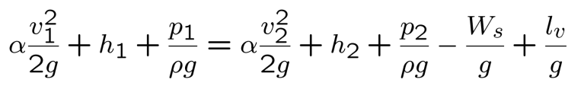........(1)

The Engineering Bernoulli Equation

## **2.2 Water Storage Tank**

Background Information and Theory:

To design this tank, the model for fluid height versus time in a tank with a uniform cross-section and circular orifice undergoing gravity-driven drainage was used

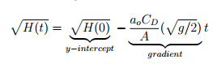....................(2)

Where g = 9.8m/s2 , A is the cross-sectional area of the tank in m2, and ao is the cross-sectional area of the orifice in m2 .

Our approach to designing the water storage tank was to model the operation of a draining tank on the small-scale testing rig, and obtain empirical values by experiment. We then confirmed that our theoretical model for tank drainage was valid. From this, we generated a model for our real world tank design by scaling up the model, using the same empirical values.

Experiment Setup and Steps:

The steps for the tank draining experiment on the testing rig were as follows:

For the set-up, the tank was rested level on the surface of the support structure. The top of the draining tube extension was set as the zero height of the water level. Lines were marked up the side of the tank in increments of 5mm in preparation for measuring the height of water in the tank. Fill the tank up to a specified height, ensuring that the orifice tap valve is closed. Perform the experiment by opening the tap value and letting the water drain out, while recording the time taken to reach every water height.

Design and Testing (rig) : data and analysis

The model of the tank was created by substituting an empirical value found from experimental data, the discharge coefficient, CD, into the theoretical model for tank drainage. To find the drainage coefficient, a linear line of best fit was fitted to the experimental data of the height of water in the tank versus time. The gradient of the line was the average rate of change in height, and the y-intercept of the line was the initial height of the tank. By comparing the gradient of the line to the expression for gradient in the theoretical model, the discharge coefficient could be calculated by rearranging the terms for gradient in equation 2.

From equation (2),

·····························(3)

Expressing equation (3) in terms of the drainage coefficient

·····························(4)

Then, equation (4) was used to calculate the value for CD, using the average gradient of change in height over time from the experiment.

## **2.3 Pump and Pipe**

The steps for the pump flow rate experiment on the tank testing rig were as follows:

For the setup, make sure the tank is resting level on the surface of the support structure. Set the top of the draining tube extension as the zero height of the water level. Then connect the like-coloured wires from the power to the pump control module as shown in figure(1), switching the voltage to 6V or 9V for different trials of data.

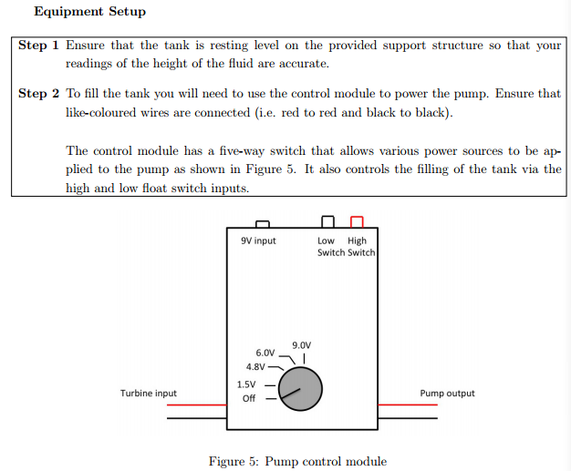

figure(1): control module

For the experiment for pumping without draining, firstly, switch the module to 9V and switch it off when the water in tank reaches the required water level, which is 10 cm. Secondly, open the tap at the orifice to let the water flow out of the tank. Thirdly, record the time in seconds every time the water level increases by 5mm. Finally, repeat these steps 3 times to get a reliable set of data.

For the experiment for pumping while draining, using the same tank rig as in the water storage experiment, ensure the water height is up to zero at beginning and the valve tap is open. Firstly, set the control module to 9V and switch the pump on. Secondly, record the time in seconds every time the water level increases by 5 milimetres, until the water height reaches 6 centimeters. Thirdly, drain the tank back to the zero water height, and change the control module to 6V. Since the flow rate for 6V was slower than the drain rate, the tank was filled to a height of 3cm before the experiment was started. Then, the steps above were repeated and the experiment was stopped when the water level stabilised at 1 centimetre.

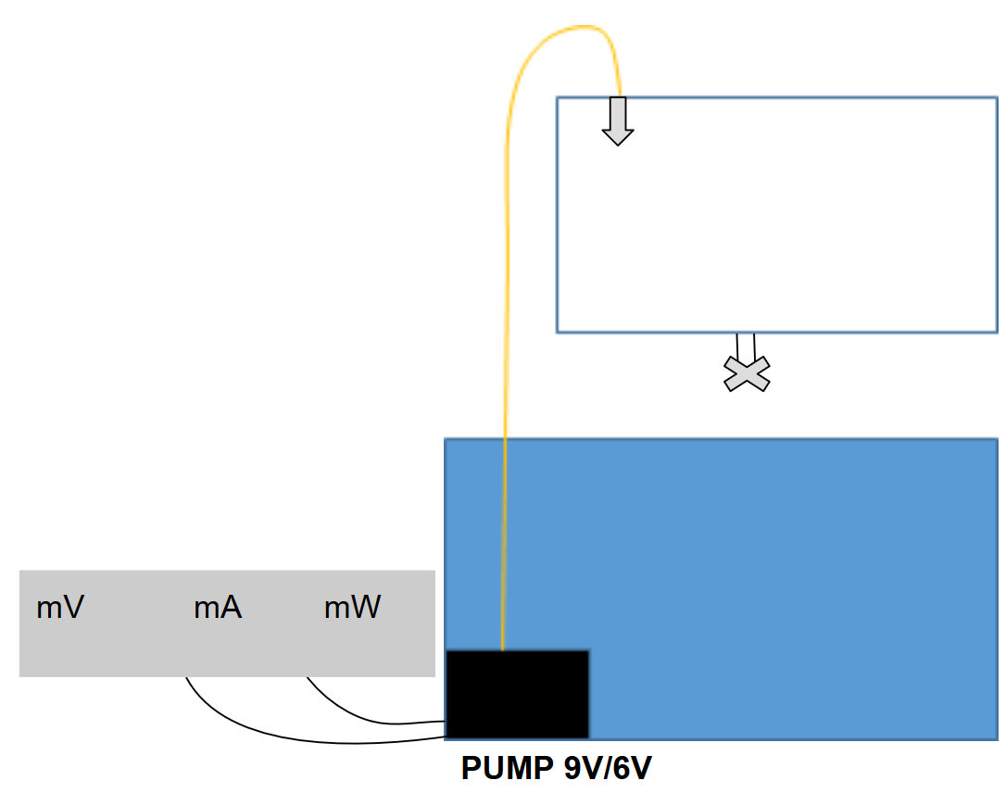

Figure #.# Pump Experiment Setup

Modelling concept and Design and Testing (rig) : data and analysis:

We use experimental rig and data plotted by matlab to finalise our design for the real-world water tank design.

Flow rate Q at pump:

Determine flow rate Q by Q=A dqdt, where A is the cross sectional area of tank in m2 and H is the height of water in tank in meters. Use matlab to plot height versus time and find out best fit linear equation, where its gradient is the flow rate of the pump.

The length of the real world pipe design is calculated based on the design specifications for the dimensions of the system, and the dimensions of the tank design, using the Pythagorean Theorem.

Pressure inside the pipe:

P in the pipe = ρgh= 470400 pa

Ρ water=1000 kg/m3

Vthe top of the pipe =Q the top of the pipe /ao = 0.0318m/s

v the pump =√ (dg(h1 + Hp – h0 – h2 )/2fL = 0.2452m/s

µ= 1.002*103N s/m2

## **2.4 Wind Turbine**

The wind turbine was designed based on the power requirement of the pump. Based on theoretical equations that modelled the operation of wind turbine blades, an experiment was performed on the small-scale testing rig to obtain empirical values for these equations. These values were then combined with the theoretical equation for the power produced by a wind turbine to produce a valid model, which would be used to choose our real world design.

The equations used to model the performance of the wind turbine blade are based on the continuity equation of aerodynamics, which describes the flow of a fixed amount of air passing through two points. Its most basic form is p1A1V1 = p2A2V2 for two points, where p is the density of air, A is the cross-sectional area, V is the velocity of the travelling air, and the resulting units are in kg/s.

Power produced by a wind turbine can be modelled using the general equation for power: P = E/t, the change in energy over time. By selecting two points in the air: the first point at the wind turbine blades, and the second point directly behind the blades, and substituting the variables for velocity from the continuity equation to find the change in kinetic energy, these two equations can be combined to describe the power generated by a wind turbine. The equation for maximum power, assuming all energy is transferred to the wind turbine becomes: P = 1/2pAVw3. However, this is not realistic, so the power coefficient Cp, was introduced to account for energy losses. Cp is dependent on the pitch angle, the angle at which the blades face the wind, and the tip speed ratio, which is the ratio of the angular velocity to the blade radius.

The steps for the turbine blade power coefficient experiment on the wind turbine testing rig were as follows:

For the setup, the wind turbine blades were attached to the blade adaptors, which were then attached to the hub of the wind turbine. The wind turbine was placed directly facing a large fan. The direction the fan was pointing in was adjusted until the direction of the wind hitting the wind turbine blades would be perpendicular to the swept area of the wind turbine blades. This was to ensure that wind would not turn the blades at an angle, creating an unaccounted change in pitch angle. Refer to figure #.# for a visual representation of the experiment setup.

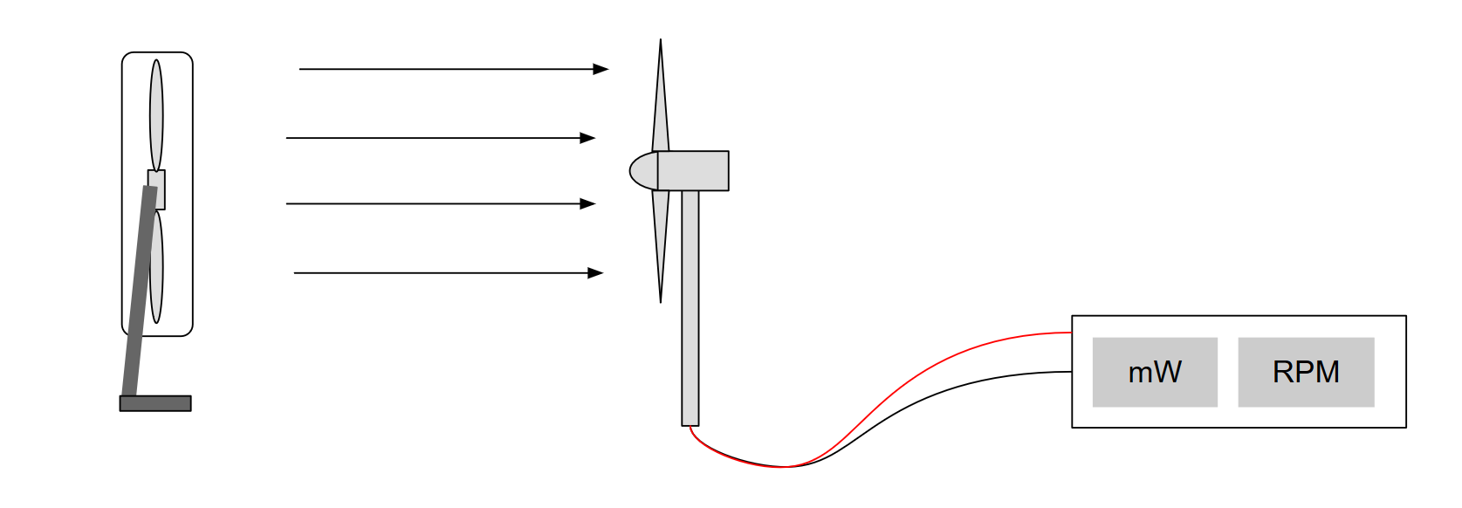

Figure #.# Wind Turbine Experiment Setup

To start measuring the power produced by the wind turbine and its RPM, first, the fan was switched on. Then, an anemograph was used to measure the wind speed at the turbine blades. The wind turbine blades were held still during this stage of the experiment, to ensure that there would be no interference with the measurements from the anemograph. Once a stable measurement of the wind speed was obtained, the blades were released and allowed to spin. Once the readings had stabilised, the RPM and power produced by the turbine was recorded.

To measure the power and RPM at a different wind speed, the fan speed was adjusted and/or the wind turbine was pushed closer or further away from the fan. At the same time, the anemograph was used to measure the wind speeds. Once an appropriate wind speed was found, the procedure above was repeated. These steps were repeated for a range of wind speeds. This process was repeated again for different blade adaptors and pitch angles of 15, 20, 30, and 35 degrees.

Modelling and Confirmation of the Model:

Since there were fluctuations in the measured RPM, RPM was plotted against wind speed and fitted to a linear relationship. The fitted RPM was used to calculate the tip speed ratio for each data point using the equation: λ = wR/Vw. The tip speed ratio, wind speed, blade radius, and power produced were used to solve for the power coefficient. The power coefficient for each tip speed ratio and pitch angle was plotted as a 3D surface plot in MATLAB to find the maximum Cp. This value was used in our calculations for the radius of the scaled-up wind turbine blade.

Design and Testing (rig): custom blades and model of CP (λ, β)

For our custom wind turbine blade design, our team decided to use a three dimensional model, which would be created using 3D printers. The design for the wind turbine blades was based on research on industry wind turbines as well as material provided in the workshops and tutorials. From this information, the cross-section of our wind turbine blade design was developed. Following instructions in the computer aided design class on creating three dimensional drawings in Autodesk Inventor, a three dimensional model of our blade design was created from the cross-sectional sketch. This file was exported to Makerbot, the School of Engineering’s 3D printing software, to be printed. To find the optimal power coefficient and pitch angle for our custom blade design, a modelling experiment was completed on the wind turbine testing rig, following the steps detailed above.

## **2.5 Water Treatment**

According to the design specifications, the water treatment tank will be a continuous flow stirred tank reactor, also known as a CFSTR. Ozone was specified as the reactant to disinfect water pumped from the well. No practical experiment was completed for this module, as ozone can be harmful to humans at high concentrations.

Equations/theory/explanations

The component mass balances in a closed reactor for a single order reaction like the decay of ozone are:

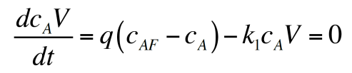

Equation #.# Mass balance for component A

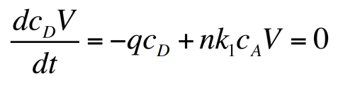

Equation #.# Mass balance for product D

However, since our water treatment tank operates at steady state, the concentration of ozone in the reactor and at the outlet of the reactor will remain the same. The derivatives for equations # and # can be set to zero to give the following equations # and #.



Equation #: mass balance for the concentration of reactant A in the reactor

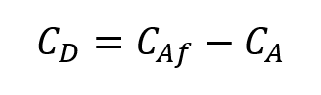

Equation #: mass balance for outlet concentration

Since ozone is harmful to humans, it must remain in the reactor for a minimum length of time to ensure that enough ozone has decayed. The amount of time it takes for one cycle of water to pass through a CFSTR is given by equation # below. The tank design must have a minimum residence time of 10 minutes.

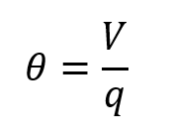

Equation #: residence time for a CFSTR

To ensure that the water treatment tank produces safe and clean drinking water for the community’s residents, it must deactivate a certain percentage of pathogens in the water. This percentage is measured in log inactivation credits. For viruses and giardia, log inactivation credits of 4 and 3 respectively are required. This corresponds to deactivation 99.99% of viruses and 99.9% of giardia in the water. Log inactivation credit is dependant on the concentration of ozone in the reactor, the temperature, and the pathogen inactivation rate constants of viruses and giardia. This is given by the Chick-Watson law (SOURCE) in the following equation #, where N is the number of pathogens, k is the pathogen inactivation rate constant, C is the concentration of the disinfectant in the reactor, and T is the temperature of the reaction.

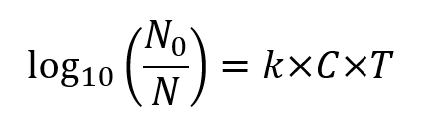

Equation #: Chick-Watson law for log inactivation credit of pathogens

Pathogen inactivation rate constants depend on the type of pathogen and the temperature of the reaction. For viruses and giardia, the inactivation rate constants are 2.1744*1.0726^(temp) and 1.038*1.0741^(temp) respectively (SOURCE).

Our team’s approach to designing the water treatment CFSTR was to first calculate the ozone reaction rate constants (k) for the temperature range of operation, which is specified to be 15-35 degrees. Then, we set an arbitrary but reasonable volume and inlet flow rate for our tank. The residence time was calculated to check whether it met the specifications of a 10 minute minimum residence time. The operation time was also calculated to ensure that the design met the specifications of an operation time between 1 and 4 hours. If the reactor design did not pass these requirements, the design was changed. If it did, our team moved on to the next step. The concentration of ozone within the reactor design was calculated using equation #, from the inlet concentration, volume, residence time, and ozone rate constant. Finally, the concentration within the reactor was used to calculate the virus and giardia log inactivation credits, using the equations # for pathogen rate constants. If the log inactivation credits were greater than 4 and 3 for viruses and giardia respectively, the design was valid.

Our team completed this process several times to find an optimal reactor design, by adjusting the values for volume and flow rate. The optimal design would have a small volume, treat water quickly, and provide safe drinking water for the community’s residents.

* Calculate ozone reaction rate constants (k) for temperature range 15-35
* Set a volume and inlet flow rate
* Calculate residence time → ensure residence time and operation time passes requirement in design specs (min residence time = 10min for safety, operation time between 1-4 hours)
* Calculate concentration of ozone within the CFSTR
* Calculate virus and giardia log inactivation credit → check if it passes 4 and 3 respectively

# 3. Results and Findings

After obtaining empirical values from these experiments and generating valid models for our real world design, the results and findings are the following.

## **3.1 Water Storage Tank**

The experiment of recording draining height versus time on the tank testing rig to find the drainage coefficient yielded the results in figure #.#.

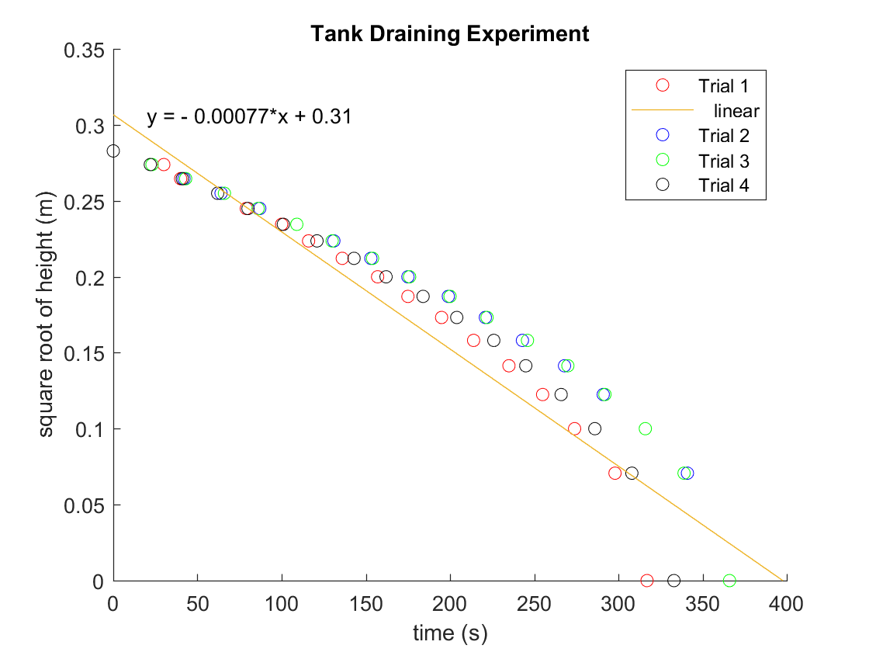

Figure #.# Graph of height vs time for four trials of draining the tank testing rig.

The discharge coefficient calculated from equation 4 using the data collected from the experiment, the gradient of the height vs time graph, is 0.79 (see appendices 1.1 for calculation of Cd).

## **3.2 Pipe and Pump**

The flow rate Q, which is the gradient of the linear line of best fit to the change in height over time, multiplied by the cross-sectional area of the tank, is 0.0000098m3/s (under 9V control module) and 0.0000058m3/s (under 6V control module). It is obvious that the flow rate under 9V pumping is higher than under 6V pumping.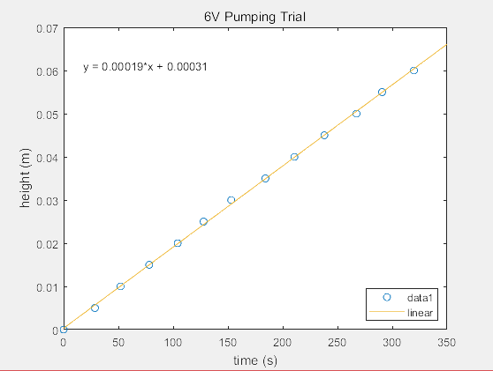

Figure #.#: Filling the tank without draining with 9V and 6V pumping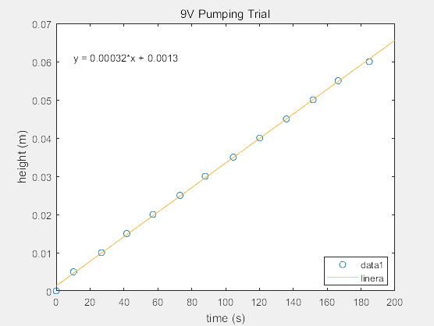

Using the equation for power P=gHpρQ, the pressure head found for the 9V pump is 35m, and the pressure head found for the 6V pump is 25m (under 6V control module)

Figure #.#: Filling the tank while draining with 9V and 6V pumping 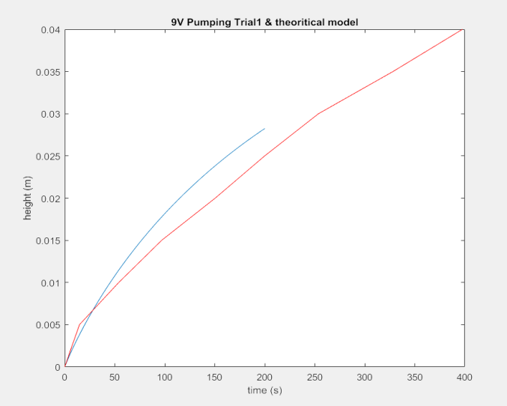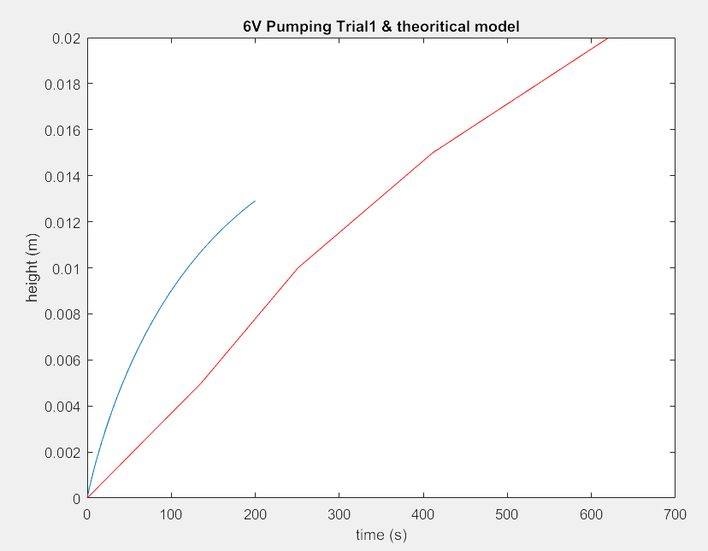

In the experiment for pumping and draining, the data for the height of water in the tank according to time was plotted against the theoretical model. As the curve of data is a close match to the theoretical model, we can confirm that the model is valid.

## **3.3 Wind Turbine**

Figure # shows the results of the power coefficient at different tip speed ratios on the testing rig with a flat blade of pitch angle zero, calculated from raw data in appendix #. The power coefficient was calculated according to the method and appendix #. Figure # shows the maximum Cp obtained from the flat blades, out of all the data points for varying tip speed ratios and pitch angles, calculated from raw data in appendix #.

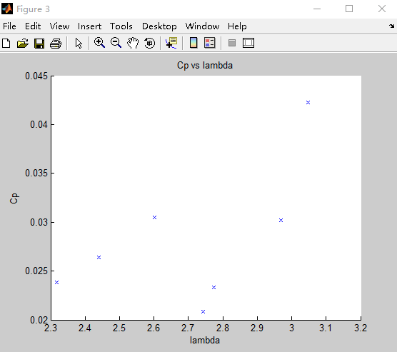

Figure #.#: Plot of CP (λ, β) for a fixed pitch flat blade with pitch angle of zero. Power coefficient calculations are provided in appendix #.#

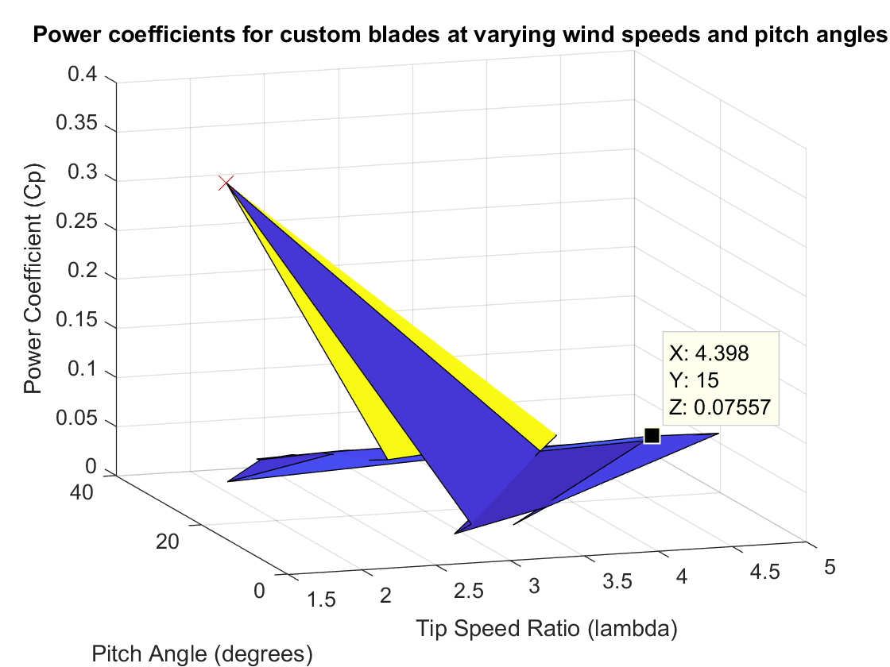

Figure #.#: Power coefficients for custom blades at varying wind speeds and pitch angles. Power coefficient calculations are provided in appendix #.#

There was an outlier in our data set for the power coefficient surface plot for the blade design. This was a maximum power coefficient of 0.3606 that occurred at a pitch angle of 15 degrees and a tip speed ratio of 1.521 that was much higher than any other data point in the results. This outlier could have been the result of errors in experiment. Accounting for this error, the highest power coefficient obtained for our blade design is 0.07557, which occurred at a pitch angle of 15 degrees and a tip speed ratio of 4.398.

## **3.4 Water Treatment**

Data Analysis (of ozone reaction rate constants)

Examine trends: how changing the volume / flow rate of the tank design affects residence/operation time, and log inactivation credit. Ozone reaction rate constants

SOURCE: workshop 10

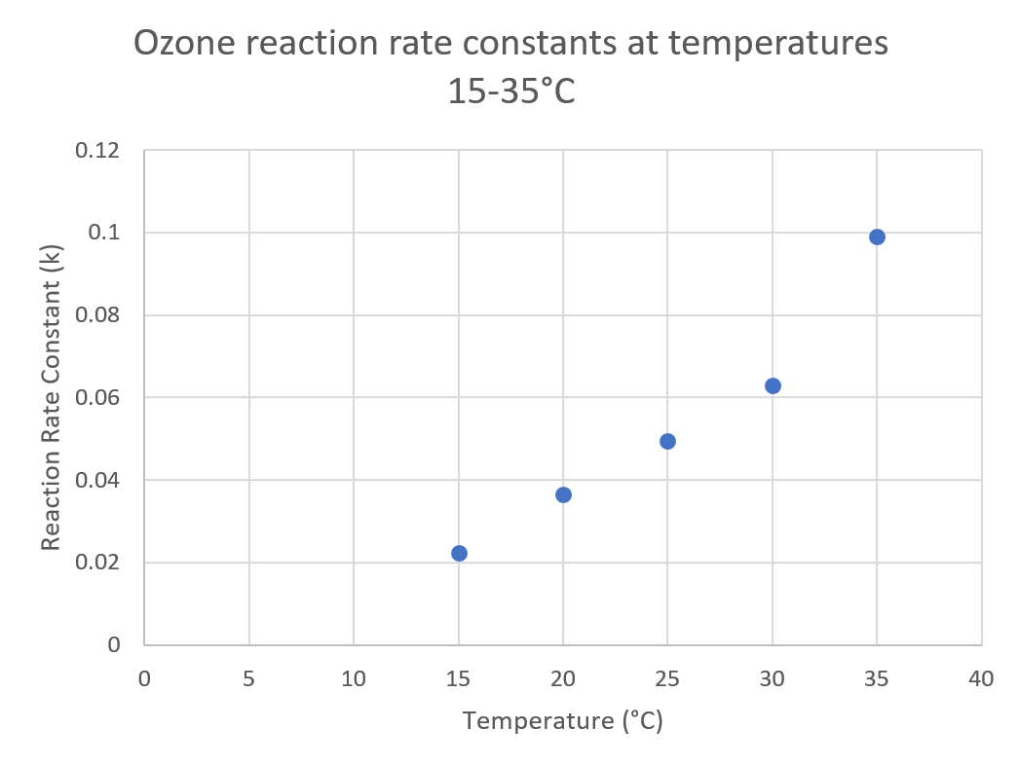

Figure #.# Ozone reaction rate constants at temperatures in range 15-35 degrees celsius. See appendices #.# for calculation.

The pathogen inactivation rate constants for viruses and giardia are 2.1744*1.0726^(temp) and 1.038*1.0741^(temp) respectively (source: workshop 10)

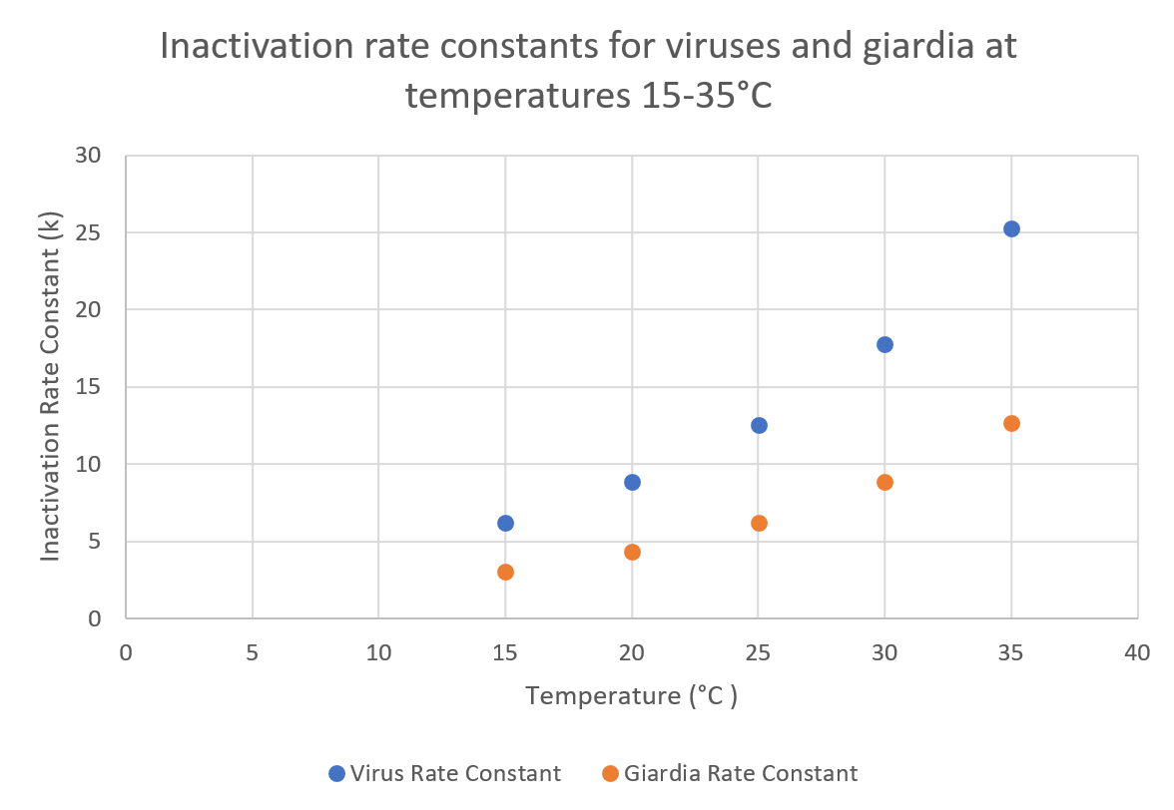

Figure #.# Inactivation rate constants for viruses and giardia for temperatures in the range of 15-35 degrees celsius. See appendices #.# for calculations.

# 4. Discussion:

## **4.1 Proposed Real World Tank Design**

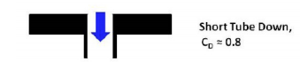

*Figure (1.1) orifice shape based on the rig experiment*

In water draining experiment, the calculated discharge coefficient is 0.79. So the orifice with the shape in figure (1.1) was chosen for our design.

The tank’s material is Galvanised steel with PE material on the surface. If the pure PE material is used, it is not strong enough to hold the huge amount of water. On the other hand, if pure galvanised steel is used, after a long time, the tank will rust and the water treatment step cannot decontaminate the metallic element in the water. Hence, PE material would be a perfect protection.

The shape of the tank is a cylinder. A cylinder has the smallest surface area of any prism, so we decided on a cylindrical tank to save on material costs. For cylinder, the surface pressure on the side-wall is the same. So, a cylindrical shape for tank is a good choice.

Our cylindrical tank has dimensions of radius 3.1025m and a height of 2m. With this size, we have included a 7 day backup period for providing the whole community with clean drinking water in case the pump breaks down. (appendices 1.6 backup period calculation)

The water demand per second for the whole community is 0.000098 m^3/s. Our designed flow out rate for the tank is a bit bigger at 0.0015 m^3/s, in order to ensure the water flowing out of the tank is enough for the community’s demand. (appendices 1.7 community water demand per second calculation) As the tank requires a flow out rate of 0.0015 m^3/s, the radius of the orifice is 0.97cm. (appendices 1.8 orifice radius calculation)

There are two sensors located in the tank. The top sensor which switches off the pump when the water level reaches its location at 2m, and the lower sensor which switches on the pump when the water level reaches its location at 1.714 m. By selecting two sensors at these locations, it takes 0.48 hours for the water level in tank to drain to the lower sensor location.

## **4.2 Proposed Real World Pipe Design**

Whilst designing the pipe which connects the pump and the first storage tank, its length, diameter, material, and type of the flow in the pipe should be taken into consideration.

Firstly, the length of the pipe can be calculated using the Pythagorean theorem. From the project specifications, the height and the horizontal distance of the pipe are known values, thus, the length can be calculated by Pythagorean theorem（ A2+B2=C2）. So, the length of the pipe is 54.12m.

Then, the diameter of the pipe is determined by our group in order to get adequate values of other variables. Since the diameter of the pipe can change both the length of wind turbines and time of filling the tank up, so the diameter which is determine should bring about proper values of them. Kinds of calculations and experiments demonstrate that when the diameter of the pipe is 0.2m, and the flow rate at the top of the pipe is 0.001m3/s, other variables such as pipe flow will be adequate, and relative velocities and flow rate can be calculated as well.

Diameter: the diameter of the pipe is not calculated when relative values, is known but it is decided by the group in order to get adequate values of other variables.

the diameter of the pipe(d) = 0.2m

the cross sectional area is (ao)= π * r 2 = 0.0314m 2

the flow rate at the top of the pipe(Q) = 0.001 m 3 /s

Moreover, material choice is also an important part of the design. Common materials for pipe construction are metal (copper is the most common), plastics such as PVC, and concrete. In this project, material costs should be reduced, but the material should still have sufficient capacity to resist water pressure. According to the relevant information and data, concrete is much cheaper than other two materials, and its capacity for pressure resistance is still higher than what we require, since the pressure in the pipe is 470400 pa (calculation in appendix 1.11). Therefore, concrete is selected as the material of the pipe.

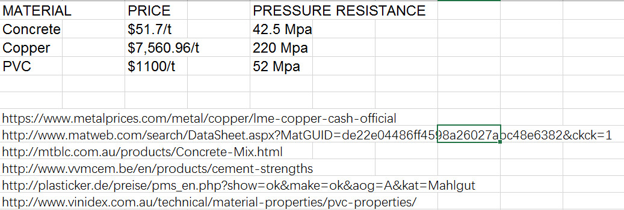

*Figure #.#: Comparison of price and pressure resistance for three common pipe materials*

Finally, the type of flow in the pipe should be determined. Reynolds number need be used here. if Re is bigger than 4000, the flow in the pipe must be turbulent. The equation is Re=ρvd/µ . p, v, d are all known data, viscosity of the flow in the pipe can be assumed as 1.002 * 103N s/m2 because of the average temperature of this place is 21°c, then, Re = 48942 at the pump and Re = 6353 at the top of the pipe, these 2 Re are both bigger than 4000, so the flow must be turbulent.

To ensure Calculate Reynold Number to determine the type of the flow in the pipe. Equation of Re=ρvd/µ. If Re>4000, the flow is turbulent, or Re<4000, the flow is laminar.

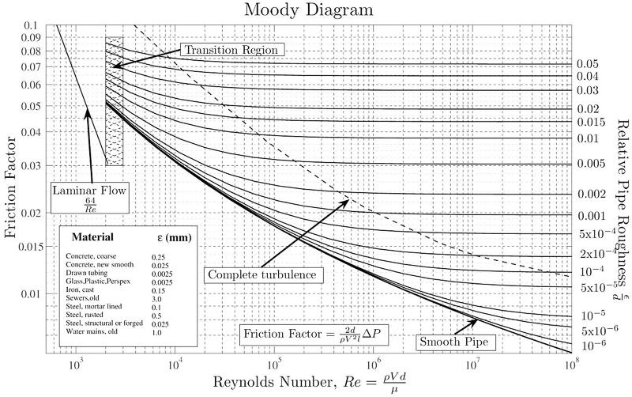

<http://lex.staticserver1.com/static/en/800/reynolds-number.jpg>

Re the pump = ρvthe pump d/µ=48942

Re the top of the pipe = ρvthe top of the pipe d/µ = 6352

Flow is turbulent.

For the pipe which connects pump and the first tank, the length is 54.12m, diameter is 0.2m, suitable material is concrete, and the inside flow is turbulent.

## **4.3 Proposed Real World Pump Design**

Since the top of our tank is has a height of 48 metres starting from the pump position, the specific work required, Ws, is 48g which is approximately 470.4 Joules. This specific work is enough for the pump because the pump just needs push water up to 48 metres.

The designed flow rate Q is 0.001m3/s. This flow rate is greater than the first tank’s outflow rate and the demand for water. Then, the time to fill the tank if empty is 55.6 hours. Due to our large tank which can supply 47 days backup, it is reasonable and acceptable.

The expected power of the pump is approximate 3623.65 Watts. The power of the pump can be calculated by , where Ws=48g, ρ=1000kg/m3, a=0.0314m2 and v= 0.2452m/s.

## **4.4 Proposed Real World Wind Turbine Design**

Our calculations are currently based off the maximum Cp we obtained using the workshop blades, as the experimental data for the custom blade design has not been completed. From the experimental data of the testing rig that was plotted in MATLAB, the maximum power coefficient occurred at a pitch angle of 20 degrees and a tip speed ratio of approx. 4.11. These values were chosen for our blade design.

Based on our current data and the power required by the pump, we have decided on a wind turbine blade of radius 13.5 m, which would make approximately 16 RPM and produce 3753W of power, assuming an average wind speed of 5.47 m/s (calculation in appendix 1.14). We calculated the radius of our wind turbine blades based on the maximum power coefficient (Cp) obtained from the experiment and the power required by the pump through rearranging the equation for power. So far, we have not designed the wind turbine for the situation where the average wind speed is lower than 5.47 m/s.

With regards to our consideration of the design problem, our wind turbine produces around 130W more than the pump’s power requirement of . We have included this contingency for an additional pressure head of 1.25m, to ensure the pump has more than enough power to move water to the top of the tank. Whilst designing the wind turbine, we have assumed that there are no structures or features of the landscape that will block the wind approaching the turbine.

Our team decided to use a three dimensional blade for our custom wind turbine blade design, because a three dimensional blade can capture more wind energy than a two dimensional one. This conclusion was based on knowledge that an aerofoil generates lift by creating an area of low pressure and high pressure on either side of the blade. This is achieved by changing the shape of the surface on either side of the blade, which cannot be done with a two dimensional design.

## **4.5 Proposed Real World Water Treatment Design**

4.5.1 Log Inactivation Credit Discussion

Caf = 0.11 mg/Litre

Our designed Volume for the CFSTR V = 570L

Our designed flow rate q = 50 litres/min

The the entire temperature range is 15, 20, 25, 30 and 35℃.

For 15 degrees, Ca = 0.189 mol/litre and Cd = __

Ozone decay rate constants Calculation:

Pathogen inactivation rate constants:

Log inaction values for viruses and Giardia inactivation rate constants (using the CFSTR model outputs)

A table & calculation to show CFSTR Operation Speciﬁcs meet the constraints and speciﬁcation of the design brief.

|  |  |  |  |  |
| --- | --- | --- | --- | --- |
| Temperature (C) | Flow Rate (m3/s) | Exit Concentration (Cd) | Virus Credit | Giardia Credit |
| 15 | 50 | 0.02234356315 | 6.217202217 | 3.030796427 |
| 20 |  |  |  |  |
| 25 |  |  |  |  |
| 30 |  |  |  |  |
| 35 |  |  |  |  |

Calculate exit concentration of ozone at each operating temperature

Calculate the log inactivation credits for viruses and Giardia at each operating temperature

4.5.

According to what aught in lectures and learned from relevant articles’ ‘ and ‘ ‘, it can be acknowledged that ozone disinfection is a widely used approach in water treatment due to its merits. Firstly, 作用强速度快. Another advantage is 应用范围广.

Admittedly, ozone water treatment is an effective method of water purification, demerits and potential negative effects of it should be taken into the consideration. As Brennan states, ozone water treatment has three important disadvantages that are reactivity, toxicity(?) and expense.

First of all, since ozone is reactive and corrosive, though it guarantee the efficiency of water disinfestation, it also can react with many kinds of metal and cause troubles . So, choices of materials about water treatment systems are restricted, and require some corrosion-resistant materials such stainless steel. Accordingly, construction costs will increase.

Potential toxicity of ozone can be the second significant demerit. Ozone is a toxic gases, excess amount of ozone may cause workers to suffer from breathing obstacles, thus, workers should not work or exposure in ozone for a long time.

Moreover, the cost of the whole water treatment is a vital issue. The production process of ozone require much more energy than others like chlorine. Specific construction materials of the system also increase the cost.besides that, the potential toxicity(?) of ozone result in extra costs of the labour charges and safety cost(?) as well. Hence, the costs of ozone water treatment system will be relatively high than alternatives.

# 5. Conclusions

In conclusion, for the experiments, we have found the discharge coefficient is 0.79. The pressure head found for the 9V pump was 35m, and the pressure head found for the 6V pump was 25m.

For our design, the tank will be made of Galvanised steel lined with PE. The dimension of our tank design will be a cylinder with a radius of 3.1025m and a height of 2.2m, with enough backup storage capacity for 7 days. As the tank requires a flow out rate of 0.0015m^3/s, the radius of the orifice is 0.97cm. The top sensor is located at a height of 2m and the lower sensor at 1.714m. By placing the two sensors at these locations, it takes 0.48 hours for the water level in tank to drain from the high sensor to the lower sensor. For the pipe connecting the pump and the first tank, it has a length of 54.12m, a diameter of 0.2m. The most suitable material for the pipe is concrete, and the flow of water inside is turbulent. The pump provides the tank with a flow rate of 0.001m^3/s, and requires 6323 W of power. The wind turbine will have a blade radius of 13.5m, and will provide 3753 W of power with an average wind speed of 5.47m/s for the pump.

Also, for this project, we need to investigate our design in various ways. There are many factors we have to consider and we must think out of the box.

# 6. Recommendations

So far in our design, a few of our parameters were designed with fixed variables, such as the temperature and wind speed in the area. In the future, we should consider a more robust design that will continue to function and supply the townspeople with clean drinking water under a variety of situations. The impact of the system on the surrounding environment has not been calculated yet, so we should consider this to ensure that the system benefits the community.

The design can be adjusted in some ways. For the next step as the tank size is redesigned, the pipe diameter must change. In addition, the water treatment module will be added in this design, we must consider the time taken by the water treatment. Hence, the flow rate will change upon the adjustments. At this stage, we need to finish the experiment of our own wind turbine blade to get more data. And the power output could be different as our result getting accurate. Moreover, for the final design, our group aim to design the whole system as a looped process to ensure that there always be some water remains in the system.

# 7. References

* Statistic Australia Official Website:
* MENTALPRICE.COM: https://www.metalprices.com/metal/copper/lme-copper-cash-official
* MATWEB: http://www.matweb.com/search/DataSheet.aspx?MatGUID=de22e04486ff4598a26027abc48e6382&ckck=1
* MOUNTBARKER: http://mtblc.com.au/products/Concrete-Mix.html
* VVM CEMENT: http://www.vvmcem.be/en/products/cementstrengths
* PLASTICKER: http://plasticker.de/preise/pms_en.php?show=ok&make=ok&aog=A&kat=Mahlgut
* VINIDEX: http://www.vinidex.com.au/technical/material-properties/pvc-properties/

# 8. Appendices:

## -.- Population Growth Calculation:

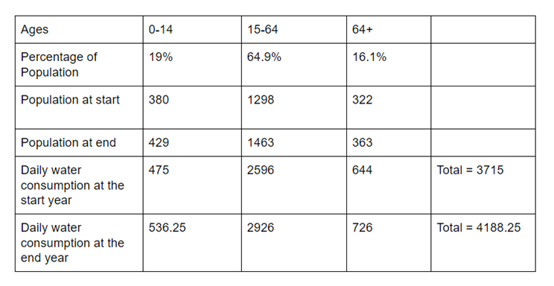

*figure(): population table*

Final population = final 0-14 citizens population + final 15-64 citizens population + final 64+ citizens population

= 429 + 1463 + 363

= 2255 people

—————————————————————————————————————————

## -.- Community Water demand per second calculation:

Design for meeting the demand of drinking water, we assume a citizen sleep 8 hours and there are 16 hours they need to drink.

A person’s average daily water demand is 2.5L.

Mayo Clinic Staff Water: How much should you drink every day? Sept. 05, 2014

<http://www.mayoclinic.org/healthy-lifestyle/nutrition-and-healthy-eating/in-depth/water/art-20044256>

Accessed May. 10, 2017.

So, whole community water demand per second = single person water demand per second × community population

= (2.5L ÷ 57600s) × 2255

= L/s

= 0.000098 m 3 /s

So, we choose 0.0001m 3 /s as the flow out rate of the tank.

Community water demand per day = 2255 * 2.5 = 5637.5

—————————————————————————————————————

## -.- backup period calculation:

Height of tank = 3 m

Radius of tank = 2.06 m

Volume of tank = π × r2 × h = 40 m3

Backup period = = 7 days

—————————————————————————————————————————

## -.- orifice radius calculation:

Calculating orifice size from desired outflow rate:

Using flow out rate for tank design:

Q = = 0.0015m 3 /s

……………………………………(1)

Rearranging for ao in equation (1) gives equations (2):

……………………………………(2)

Where A is the bottom area of the tank. H is the height of water level. CD is discharge coefficient = 0.79. And g = 9.8m/s2. Δt = change of time(s).

Substituting A = π × r2 = 13.33 m2, H(0) = 3m, H(t) = 2.6571m, Δt = V / Qout = 1757s

We get a0 = 0.0004m2

———————————————————————————————————————————

## Tank Draining Experiment and Calculation of Cd:

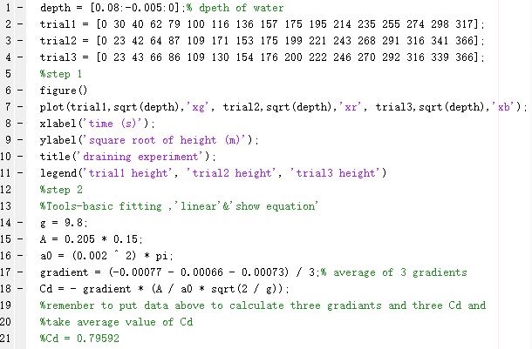

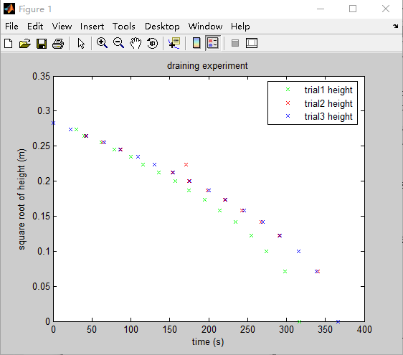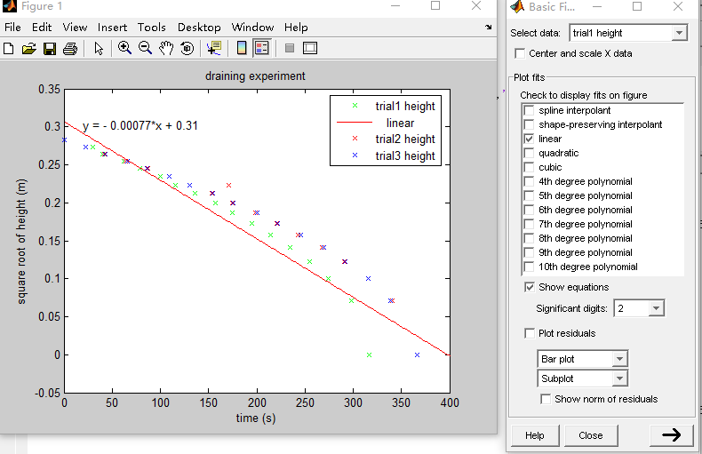

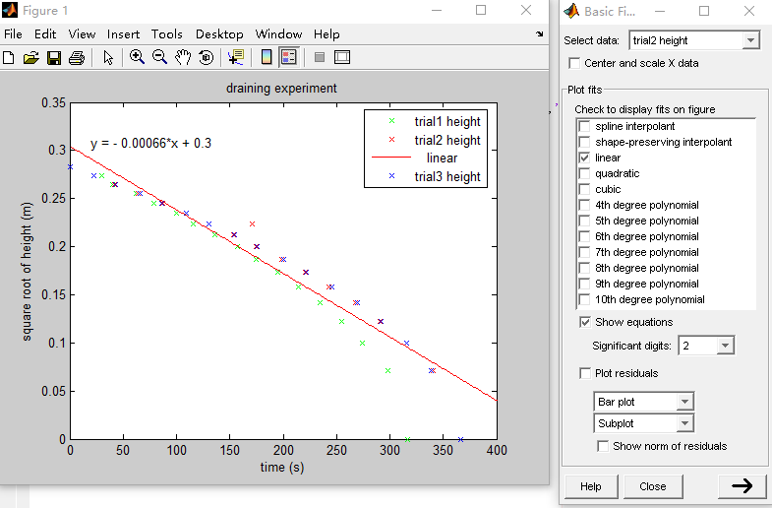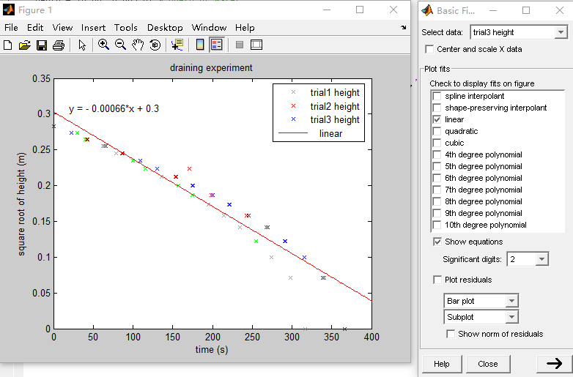

—————————————————————————————————————————

## Water draining data:

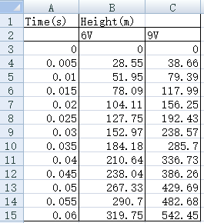

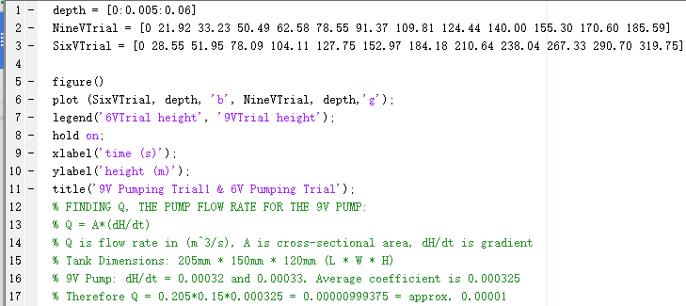

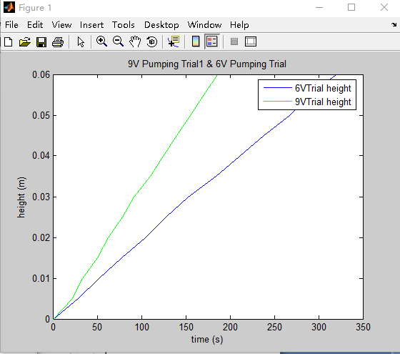

—————————————————————————————————————————

## Pipe length

Pythagorean theorem（ A2+B2=C2）.

Length of the pipe = √(horizontal distance of the pipe) 2+ (height of the pipe) 2 = √(25m) 2+ (10m+35m+3m) 2 = 54.12m

Horizontal distance of the pipe = 25m

Height of the pipe = 10m+35m+3m =48m

——————————————————————————————————————————

## Pipe Diameter:

the diameter of the pipe(d) = 0.2m

the cross sectional is (ao)= π * r 2 = 0.0314m 2

the flow rate at the top of the pipe(Q) = 0.001 m 3 /s

——————————————————————————————————————————

## Pressure inside the pipe:

P in the pipe = ρgh= 470400 pa

——————————————————————————————————————————

## Calculation for Reynold’s Number, to confirm the type of flow in the pipe:

Re = ρv d/µ

Re the pump = ρvthe pump d/µ=48942

Re the top of the pipe = ρvthe top of the pipe d/µ = 6352

————————————————————————————————————————

## Pump power:

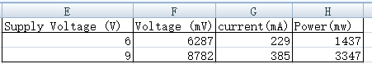

—————————————————————————————————————————

## Turbine experimental data:

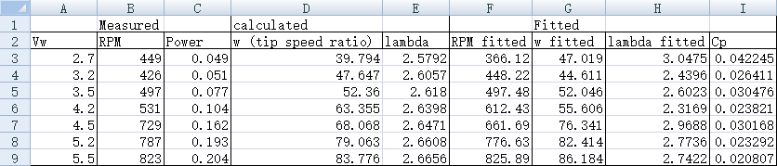

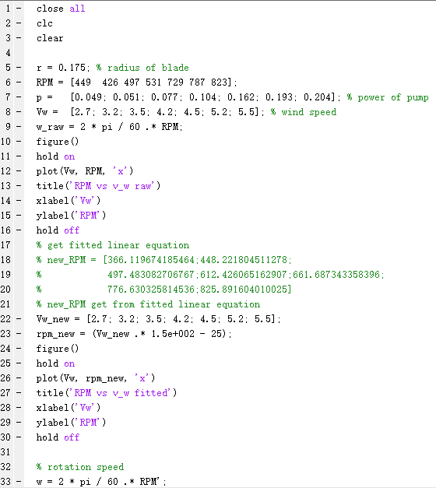

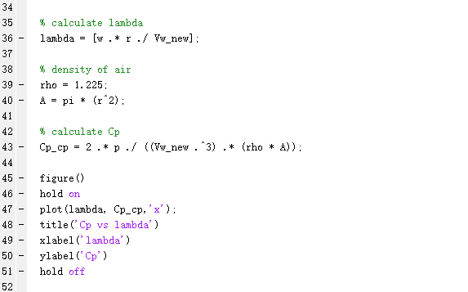

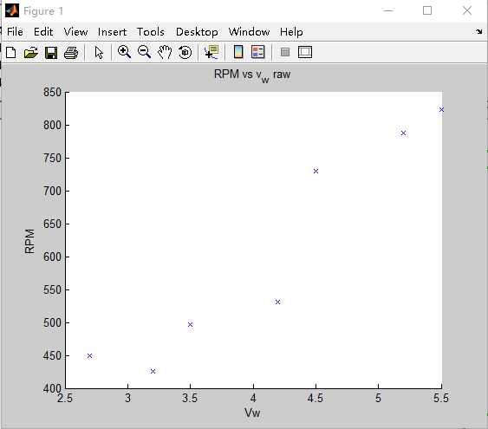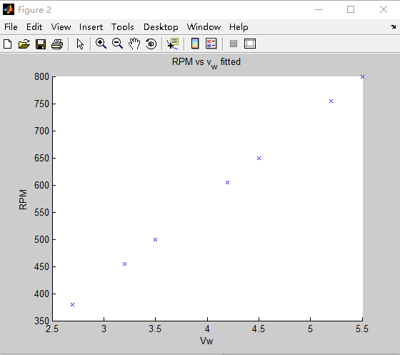

Figure (1) Figure (2)

—————————————————————————————————————————

## Calculation of wind turbine blade radius

From ,

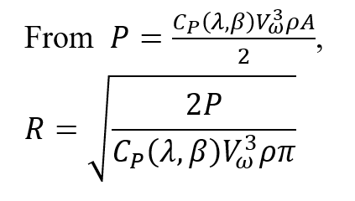

Substituting values for pump power, Cp, wind speed, and the density of air:

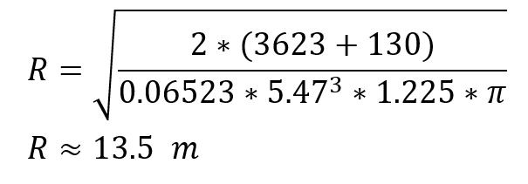

—————————————————————————————————————————

## Whole year power calculation:

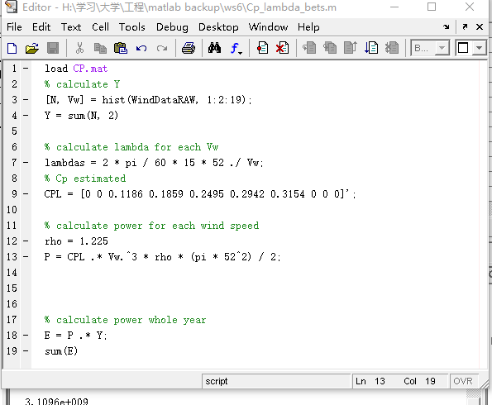

—————————————————————————————————————

1.14 Calculation of power coefficient and tip speed ratio for graph of power coefficient vs tip speed ratio vs pitch angle for flat blades

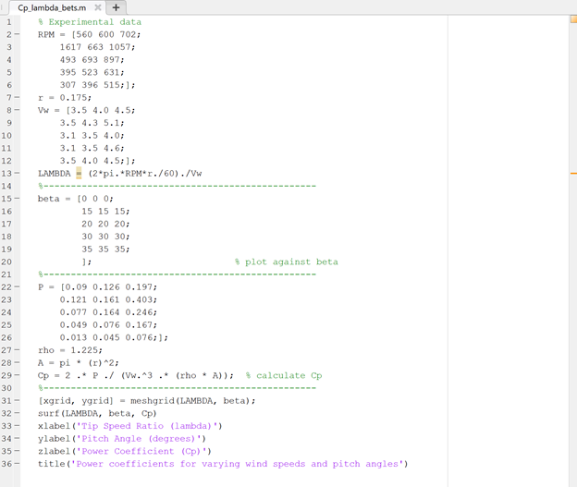

## Calculation of ozone reaction rate constants

Using equation #.#, the reaction rate constants for ozone are:

|  |  |  |
| --- | --- | --- |
| Temperature | Half life of ozone (min) | Reaction rate constant (k) |
| 15 | 31 | = ln(0.5)/-31 = 0.02235958647 |
| 20 | 19 | = ln(0.5)/-19 = 0.03648143056 |
| 25 | 14 | = ln(0.5)/-14 = 0.0495105129 |
| 30 | 11 | = ln(0.5)/-11 = 0.06301338005 |
| 35 | 7 | = ln(0.5)/-7 = 0.09902102579 |

Source: Workshop 10

Report Draft: 15 pages

Final Report: 40 pages

Instruction:

* Format size: 11 or 12
* Double lined
* Arial type

Structure:

* Cover Page
  + Title
  + Names
  + Course Name / Department / Organisation
  + Team Name
  + Date of Submission
* Abstract (200 words)
  + State topic and purpose / aim / objective of report
  + State approach and experimental / research methods used
  + Summarise main results / findings
  + Outline conclusions
  + Recommendations
* Table of Contents
  + Contain page numbers and sub-headings
* Introduction
  + State context
  + Explain relevant background information
  + State purpose of report and aims of project
  + Outline limits / scope
  + Provide definitions and key terms related to key concepts
* Method
  + How project was carried out
  + How data was collected
  + For each module: experiment, modelling, design and testing, proposed real world design
* Results / Findings
  + What happened / what was found + cover the checklists
  + Visual and concise
* Discussion
  + Identify main themes
  + Interpret / analyse results to support findings
  + Link results to similar research or experiments and to each other
* Conclusions
  + Brief summary of key findings or information
  + Highlight major outcomes of investigation + their significance
  + State whether aims have been achieved
* Recommendations
  + Suggest future actions (and make them clear)
  + Focus on main objective and support it with other suggestions
  + Use verbs like ‘should’, ‘could’, and ‘may’
* References
  + Reference list:
    - In text referencing

- Bibliography:

- material consulted during the research study, but not referred to in the

report

* Appendices

- Associated materials.

- Too detailed (e.g. large tables of data)

- intermediate (e.g. MATLAB code)

- Abstract

- Each appendix must be given a number (or letter) and title

- Each appendix must be referred to by its number (or letter) when mentioned in the

body of the report.